**User manual for the program "Sqrt" in accordance with GOST RD 50-34.698-90 (link to the source) authorship Philip Verholantsev, Vladislav Stolnikov and Vasily Tishchenko (here in after referred to as the Developers), group FZ-11 of the Faculty of Physics**

**Methods and tools for collective development of software systems, Perm, Perm State National Research University 2021**

**Contents**

**1. Introduction** 2

**1.1. Application area** 2

**1.2. Short description** 2

**1.3. User training level** 2

**1.4. List of operational documentation that the user needs to familiarize himself with** 2

**2. Purpose and conditions of application of the Application** 2

**3. Preparation for work** 2

**3.1. Composition and content of the distribution data carrier** 2

**3.2. Order of loading data and programs** 2

**3.3. Functionality check procedure** 2

**4. Description of operations** 2

**4.1. Functions and tasks performed** 3

**5.** **Emergency situations** 11

**1. Introduction**

**1.1. Application area**

There are no requirements

**1.2. Short description**

The My Root program is a small rectangular window with two tabs, a keyboard and a menu.

**1.3. User training level**

The user of this system must be able to run files with the .exe extension (for Windows OS), extension (for Linux OS), extension (for MacOS) (hereinafter referred to as the Application)

**1.4. List of operational documentation that the user needs to familiarize himself with**

User's manual

**2. Purpose and conditions of application of the Application**

The application is intended to demonstrate hashing algorithms for educational purposes

**3. Preparation for work**

**3.1. Composition and content of the distribution data carrier**

To work with the Application, you need the following software:

Installed OS Windows 7/8/10 or earlier with adequate operation of the application (that is, it does not have malware, and also meets the minimum system requirements specified in the terms of reference)

Or OC Linux / MacOS (depending on the version of the program) with the same requirements for work

**3.2. Order of loading data and programs**

Download a file with .exe extension (for Windows OS), extension (for Linux OS), extension (for MacOS)

**3.3. Functionality check procedure**

To check the availability of the Application:

Launch the OS and open the executable file with the .exe extension (for Windows OS), extension (for Linux OS), extension (for MacOS)

**• 4. Description of operations**

**4.1. Functions and tasks performed**

The application performs the functions and tasks shown in the table below:

|  |  |  |
| --- | --- | --- |
| **Functions** | **Tasks** | **Description** |
| Finds a square root from an arithmetic number | Finding a square root result | During this task, the App user needs to press the appropriate button |
| Finds a square root from a complex number | Finding a square root result | During this task, the App user needs to press the appropriate button |

**4.2. Description of the operations of the technological process of data processing required to perform tasks.**

Below is an example of custom operations.

1. When you open the application, you will be greeted with the following window:

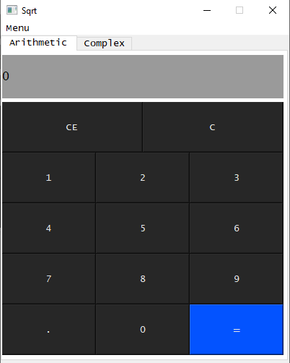

2.Choose the tab you need depending on what roots you want to find

2.1 Arithmetic roots

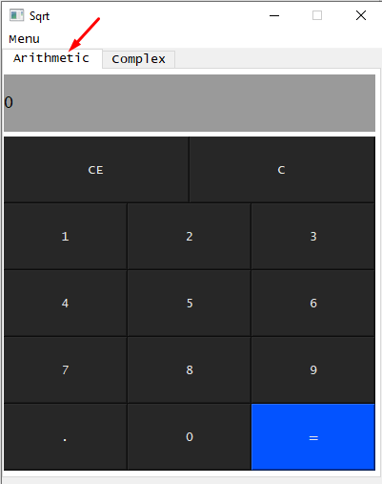

2.2 Complex roots

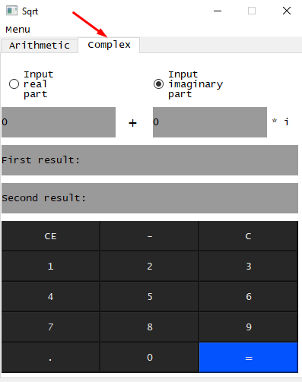

3. Working in the Arithmetic window

3.1 Using the highlighted buttons, enter the number from which you want to extract the root

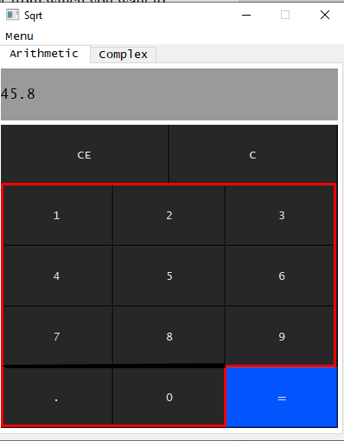

3.2 Press this button to receive an answer

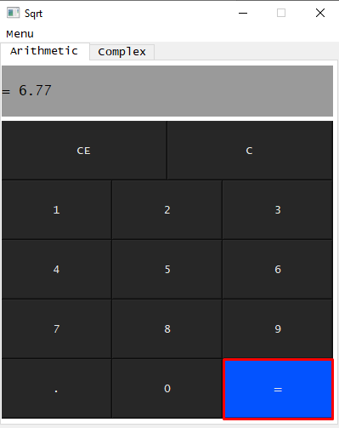

3.3 Using this button, you can completely erase the answer or delete one entered character from right to left

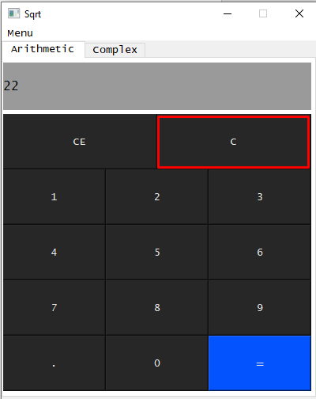

3.4 Using this button, you can completely erase the answer or delete the entire entered value

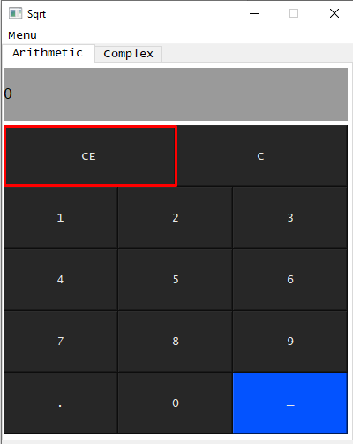

4 . Working in the Integrated Window

Complex numbers are entered in the format ("integer part") + ("coefficient at i") i

Example: 4 + 2i

4.1 Choose which part of a complex number you are going to enter

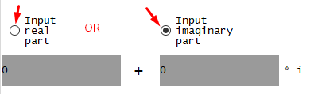

4.2 Using the highlighted buttons, enter the number in the corresponding cell

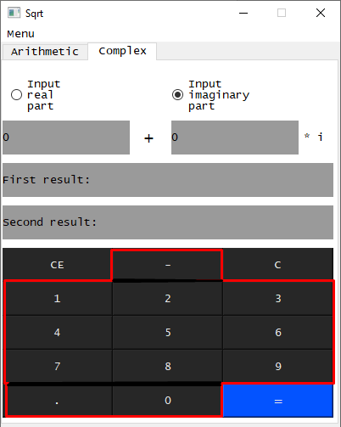

4.3 Using this button, display the result in the fields signed below

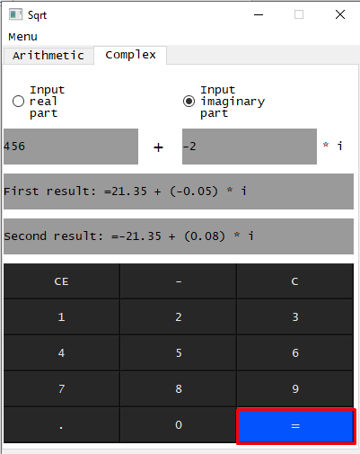

4.4 This button will erase the answer and / or one entered character from the selected window

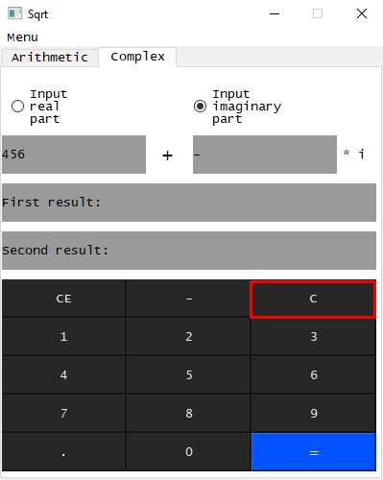

4.5 This button will erase the answer and all entered data

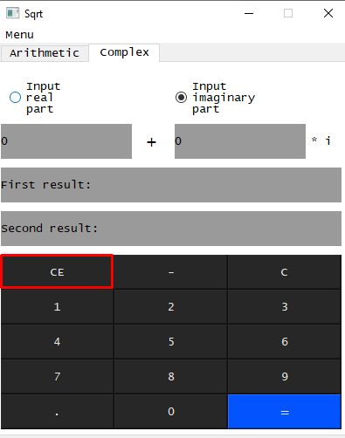

5. The menu is called by this button in the program

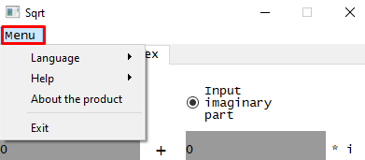

5.1 Then you can select the language

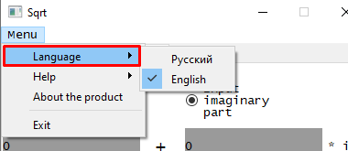

5.2 Call up help or go to the support forum

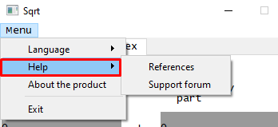

5.3 Button "About" will show information about the program

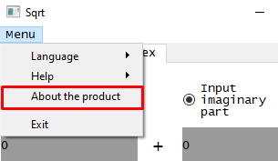

5.4 The "Exit" button will close the program

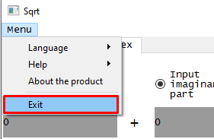

## 5. Emergency situations

The likelihood of these situations is minimized, since the reliability of the Application depends on the reliability of the OS. If there is a need for technical support, please contact the Developers of this program through the appropriate button